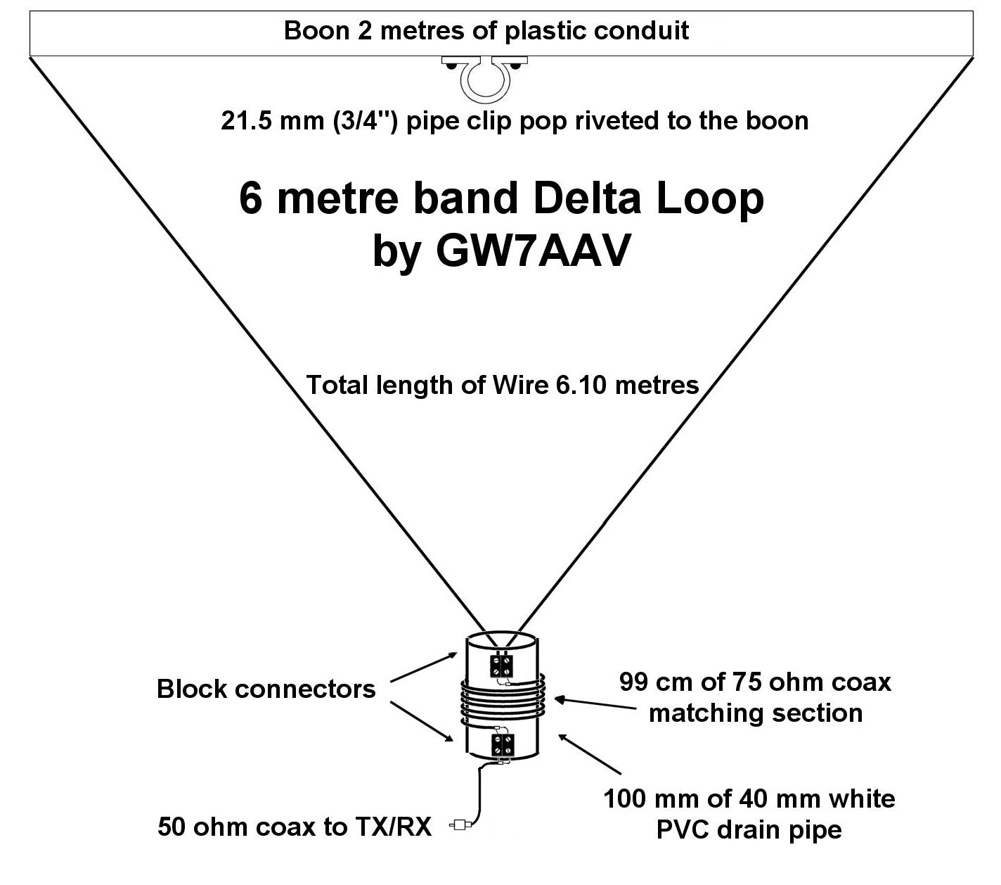
The principles of the Delta Loop are well documented and there is nothing new in my design. This one was made to fit on to a 25/30-foot fishing pole of the type used by a lot of Summits on the Air operators as a mast. For portable use the boom will be joined in the centre so that it breaks down into a manageable size. This prototype is intended for home use and hopefully a refined version for portable will shortly be made. It would be ideal as a loft-based antenna and during the sporadic E season.

Delta loops have an impedance of around 100 ohms therefore a quarter wave of 75 ohm in the feeder will bring the impedance to near enough the required 50 ohms that is expected at the transmitter. This matching section can be rough wound and taped but I choose to neaten things up by using a piece of white PVC pipe as a former.

The matching section is critical and you need to have 99 cm of shielded section. The trick is to cut 105 cm of 75 ohm coax and then strip back 3 cm either end to make the tails which are tinned with solder and screwed into the block connectors.

This was a worked first time design and the SWR is 1 - 1 from 50 – 51.5mHz and reaches a reasonable 1.7 – 1 at 52mHz It is horizontal polarised and was cut for the SSB section. Do not forget to waterproof the matching section.

