Connecting the Yaesu Quadra (VL-1000) to an Icom Exciter

Fig. 1: Interface Cable, Icom ACC2 to Quadra BAND DATA 2
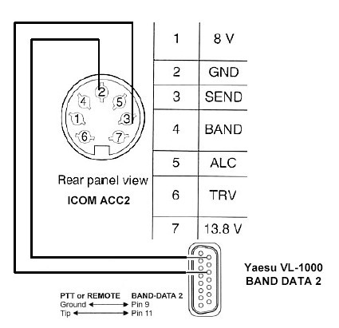

Procedure:
- Reprogram the Quadra amplifier per Yaesu's instructions, to activate 10 and 12m; this reconfigures the amplifier as the "International" model.
- On the exciter, set the RF POWER control to 100W. The VL-1000 requires at least 75W of drive for correct auto-tuning or bandswitching.
- Set the REMOTE switch on the VL-1000 rear panel to OFF (down).
- If remote power on/off switching from the exciter is desired, connect Band Data 2, Pin 1 (+13.6V) to ACC2 Pin 7 (13.8V) as illustrated here. Set the REMOTE switch on the VL-1000 rear panel to ON (up).
- Connect the Quadra to the Icom exciter, via 4 cables: RF, ALC (mandatory), PTT and remote keying interface. The latter allows the Quadra to key the exciter for tuning when the F.SET or TUNE button is pressed. The remote keying interface cable is a shielded cable which connects VL-1000 Amplifier Band Data 2 (DB15) to Icom ACC2 (7-pin DIN). Connect Band Data 2, Pin 9 (F SET COMMON) via shield to ACC2 Pin 2 (GND). Connect Band Data 2, Pin 11 (F SET 2) via center conductor to ACC2 Pin 3 (SEND). See Figure 1 above.
- Connect the ALC cable from the ALC 1 jack on the VL-1000 to the ALC jack on the Icom exciter. Connect the PTT cable from the PTT 1 jack on the VL-1000 to the SEND or RELAY jack on the Icom exciter. (Note: If the exciter is an IC-7600, IC-7700 or IC-7800, set SEND Relay Type to MOS-FET in ACC set menu.)
- Prior to pressing F.SET or TUNE, set the exciter to RTTY or FM mode to transmit a continuous carrier to the Quadra. When the bandswitching or auto-tuning cycle is complete, select the desired operating mode.
- ALC calibration: Set the Quadra's ALC level to limit power output to 1 kW, corresponding to approximately 80W of drive. It is sufficient to calibrate the ALC on one band; the power output is almost constant across all HF bands. (Note: If the exciter power output can exceed 100W, as is the case for the IC-775, IC-781, IC-7700 and IC-7800, the input attenuator ATT should be enabled). Refer to VL-1000 User Manual, p. 12. The Quadra's ALC line is compatible with that of an Icom exciter (0 to -10V DC). The typical ALC voltage for 1 kW output is about -4V DC.
- The RF input impedance of the Quadra is 50 ohms resistive (frequency-independent). It is therefore unnecessary to engage the transceiver’s autotuner when driving the Quadra.
- Note: As Icom exciters do not support the Yaesu Band Data 1 cable, the following Quadra features are not available in this configuration:
- remote power on/off switching from the exciter (but refer to Paragraph 4 above)
- automatic antenna selection by band
- the transmit-inhibit line (for QSK operation)
- automatic generation of an 80 ~ 100W CW tuning carrier by the exciter (irrespective of current operating mode) when pressing F.SET or TUNE (refer to Paragraph 6 above)
Copyright © 2002-2011 A. Farson VA7OJ/AB4OJ. All rights reserved. Last updated 01/20/11
Principio del formulario
Final del formulario

